**SQL TASK 3**

**Name:** Syafeeqa Aqeela binti Roshidi

**Class:** 1K6

**2. TABLE STRUCTURE**

**a. Create a books table with these essential fields:  
 - book_id (Primary Key)**

**- title**

**- author**

**- borrowed_date (YYYY-MM-DD)**

**3. REQUIRED OPERATION**

**a. Data Entry**

1. Add at least 5 books
2. Include title, author, and borrowed_date
3. Use proper date format (YYYY-MM-DD)

**b. Basic Queries**

1. List All books

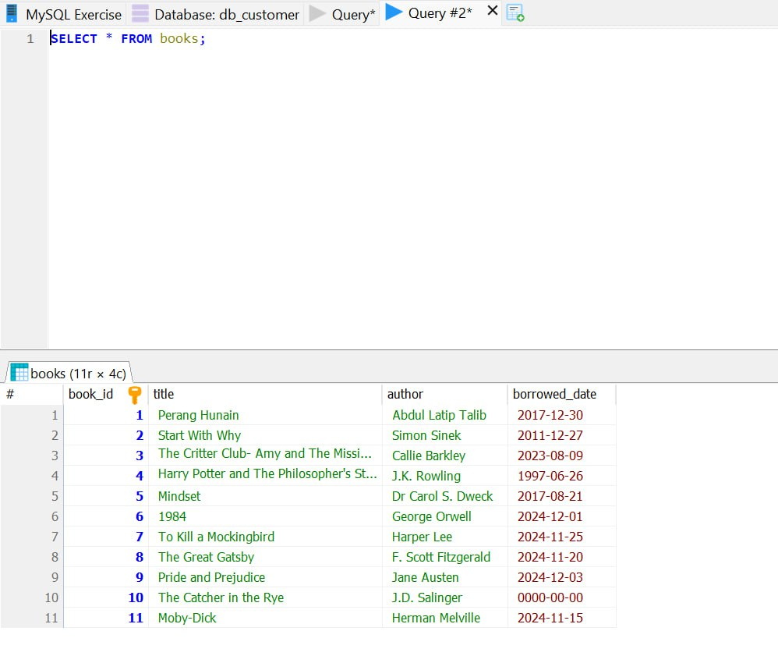

1. Find books by author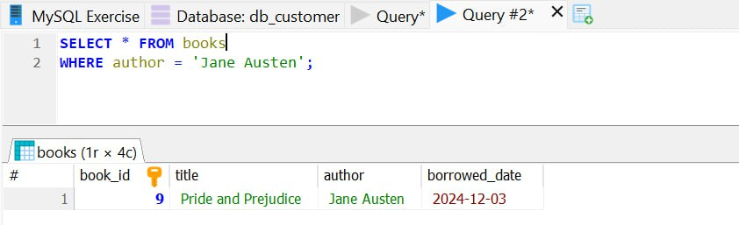
2. Find books borrowed on a specific date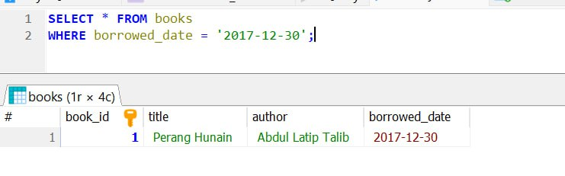
3. Find books borrowed after a certain date

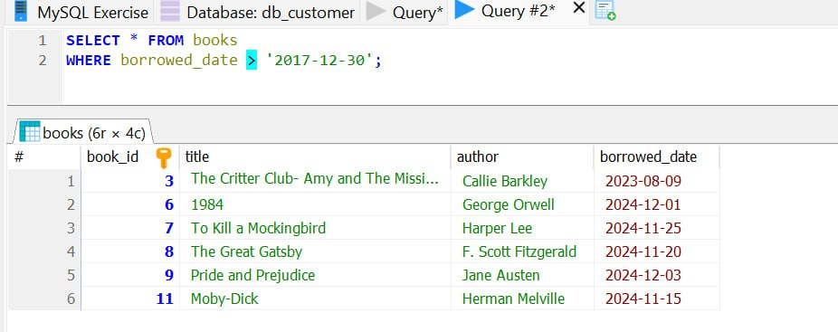

**c. Data Manipulation**

1. **Update borrowed_date**

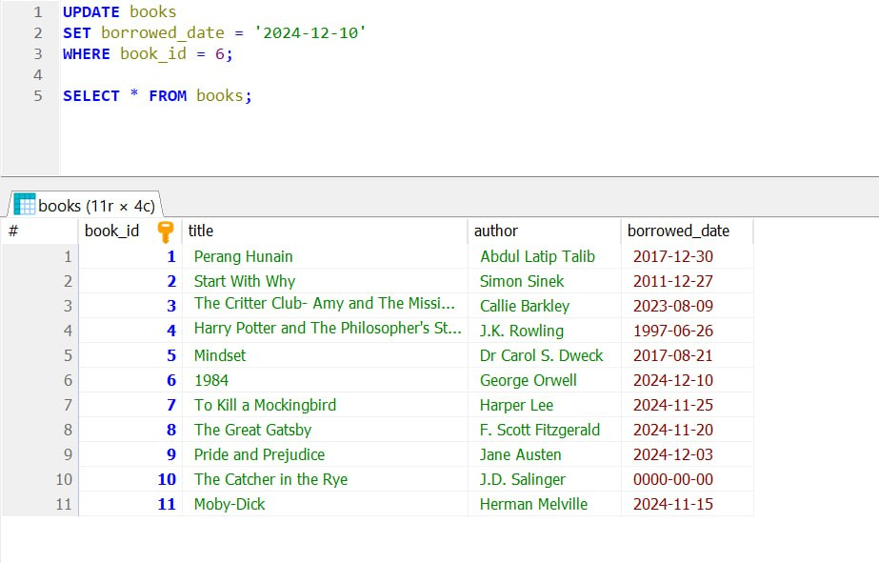

1. **Delete a book**

**3. Re-add a deleted book**